Digital Agenda Scoreboard
This is the report of the work being done under the service contracts
- Upload and update operations for the Digital Agenda Scoreboard Website (TenForce)
- Upgrade of the visualization tool running on the scoreboard.lod2.eu website (InfAI)

Chapter 1 provides an overview of the updates done
Chapter 2 describes the installation rules.

Updates w.r.t. situation of Feb 2012
The next list provides an high level overview of the changes.

Data updates
- april 2012: a new data set has been uploaded & set online
- may 2012: test version of the final data uploaded to the test system.
- june 2012: the final data set has been uploaded & set online

System updates
- new version of HighCharts : v2.2.3 (2012-05-07)

Web Application functionality update
- New functionality print all indicators on the Country Profile: all charts for each indicator group have been constructed on one webpage. On printing this webpage each chart is positioned on a separate page.
- Removal of the all_indicators Country Profile selection has been removed.
  - changed parameter indicatorgroup
- Selection of countries in Timeline requires user confirmation now (allows to select multiple countries in one selection round).
- Parameters of selections were changed. (Identifiers for encoding)
- Generated filename for csv export is shortened, otherwise MS Excel could not open correctly the file from out of IE.
- Navigation between different scenario’s remember the selected indicator (between scenario 1,2 &3).
- Download section updated with new data dumps and updated examples addressing the new structure of the DataCube.
- Changed database connection parameters to receive data entities in UTF-8 ,which addresses much of the character encoding issues.
- Small visualisation improvements on the charts.
- In certain cases the export of CSV was incorrect.

Database updates
- Changed the datatype of value column (data table) (from String to Float).
- Changed empty value fields in CSV export of data spreadsheet to “NULL”
- Changed collation / character type of different columns to store special chars properly.

RDF structure update
- The RDF structure is now in line with the European Commission Dataportal requirements for DataCube datasets.
- The indicators are now a separate dimension referenced by observations,
  - Added a class description for the newly created dimension elements.
  - Added a name-space for dimension elements.
- Instead of using plain text labels for the Time & Country dimension, these are now proper URI’s in the Digital Agenda Scoreboard data-space,
  - Added a class description for the year elements and used a class description for spatial elements of country dimensions.
  - Added two name-spaces for elements of both new dimension.

Known outstanding issues
- Downloading png, svg or pdf versions of the scatterplot charts in IE7 and IE8 fails.
  - The origin of this problem are the special characters and layout in the titles. E.g. ‘&’ and <br/> to break the title in 2 lines, are not properly handled.
- When printing in landscape mode in IE9 the charts disappear.
  - The exact reason for this behaviour is not found. Printing in portrait mode works fine (although the graphs are smaller)

These issues are known at the time of delivery of the final version and are due to limitations in the IE support for Highcharts.

Postponed issues, in agreement with DG INFSO
- Selection of indicators w.r.t. units. Now an indicator is a combination of a statistical variable, breakdown and a unit. The idea was to allow end-users to select between items of variable-breakdown combinations and then if needed a selection of the unit (e.g. between absolute and percentage)

Installation guide
The Digital Agenda Scoreboard (Web-Application ) is deployed on a server using the following hardware and software components. The exported RDF DataCube is deployed in an OntoWiki installation (http://data.lod2.eu) and interlinked with the Web-Application (download page). The Hardware and Software components used as a basis for OntoWiki are included in the following lists as well.

Hardware components
- Server 4 Cores
- 8GB of RAM
- 12 GB SWAP
- 500 GB HD

Software components:
- PHP 5.3.2-1ubuntu4.9 with Suhosin-Patch (cli) (built: May 3 2011 00:45:52)
- Mysql Ver 14.14 Distrib 5.1.41, for debian-linux-gnu (x86_64) using readline 6.1
- Server version: Apache/2.2.14 (Ubuntu) Server built: Nov 18 2010 21:19:09
- php modules: mysql, odbc, PDO, curl, tidy
- Highcharts JS v2.2.3 (2012-05-07)
- OntoWiki: early april 2011 snapshot of the OntoWiki project
- Virtuoso: 6.1.2.

The system architecture is visualized in the the following depiction.

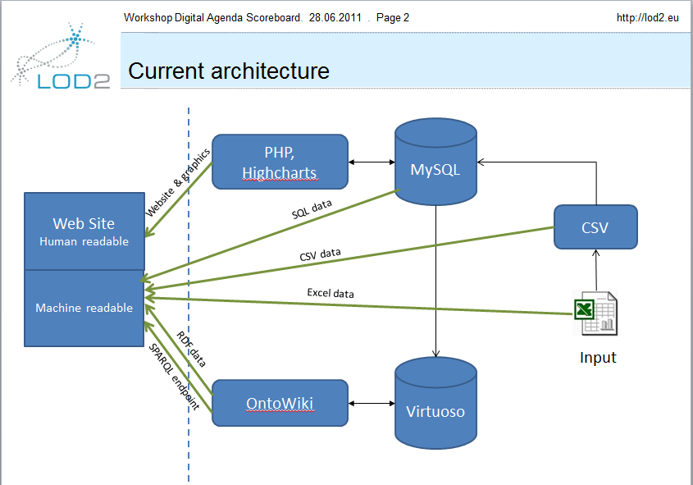
The next basic procedures have been applied to setup the machine and some data processing.

Source Code and Data Dump

The scoreboard php code is located in the file scoreboard.tar.gz.
The dginfso.sql.gz contains a sql dump of the latest database.

Installation
In the following we sketch the installation of the Scoreboard Web Application.

- Copy sources to htdocs
- Create virtual host in your apache config. (or make it otherwise available via web)
- Create a MySQL-Database: (dbname / username / password) and upload the attached sql file
- Open Connector.php (Scoreboard root-folder):
- Change the following attributes in the constructor according the credentials of the newly created database
$host = "localhost";
$dbname = "dginfso";
$username = "root";
$password = "root";

- Make sure that the logs folder (scoreboard root directory) is writeable or change the following parameter in the Connector class (constructor)
$logfile = "logs/scoreboard.log";

Export of the DataCube:
The RDF DataCube can be exported with different possibilities. One possibility is to select a set of information using the different scenarios and its offered filter criterion. Then the user can click the link “Export RDF” which contain all the information visible in the chart as well. The other possibility is to extract the complete DataCube by using the following two parameters:
- scenario with its value “5” and
- export with its value “rdf”
As an example: http://<scoreboard-webroot>/?scenario=5&export=rdf
It is recommended to do it with wget or curl like:
wget "http://<scoreboard-webroot>/?scenario=5&export=rdf" > datacube.ttl

In the directory content one finds the results of the intermediate processing steps
It starts from the Excel sheet, convert it to the csv's, upload it in the sql database and then convert it to the RDF.
The transformation rules of the rdf are embedded in the scoreboard php code.

